Brand Style Guide: The Center for Inclusive Growth

1. Logo Guidelines
Acceptable Logo Variations for The Center:
- Monochrome (black and white): The logo can be reproduced in a single color, either solid black or solid white, for use on a variety of backgrounds.
- Alternative versions for dark/light backgrounds: A white version of the logo should be used on dark backgrounds to ensure legibility.

Acceptable Logo Variations for BUY NEW HAVEN
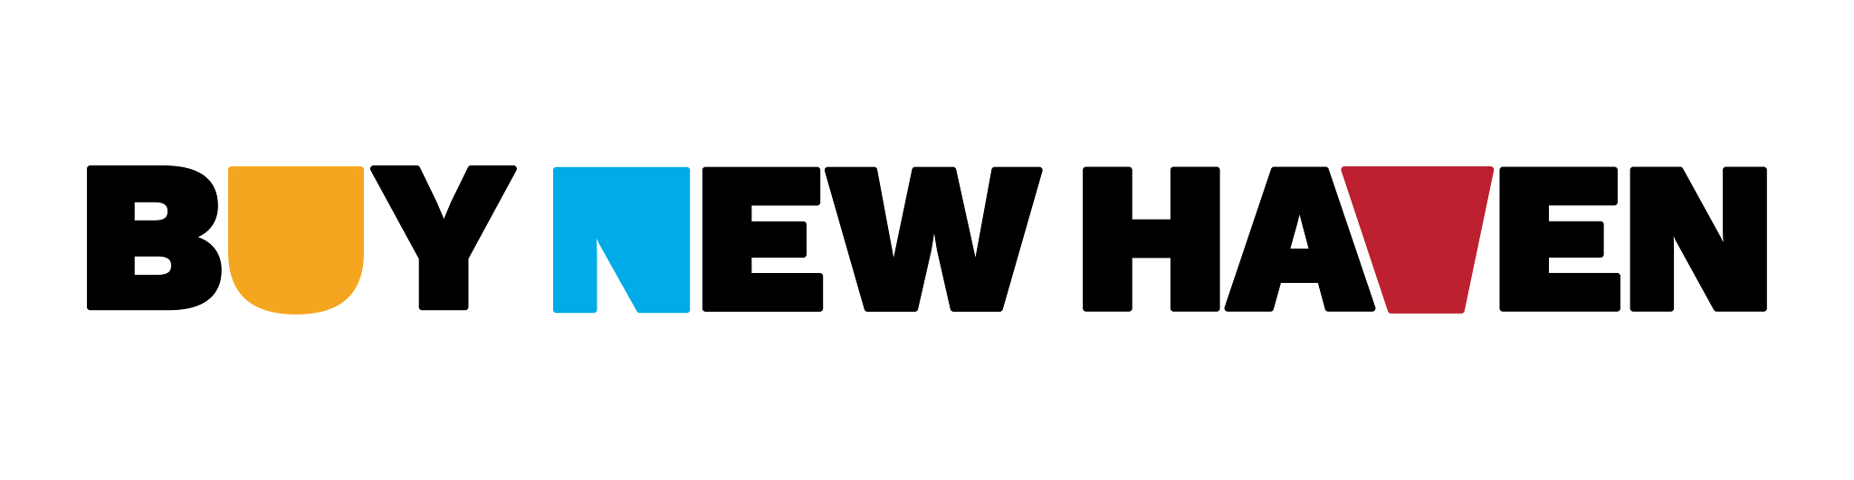
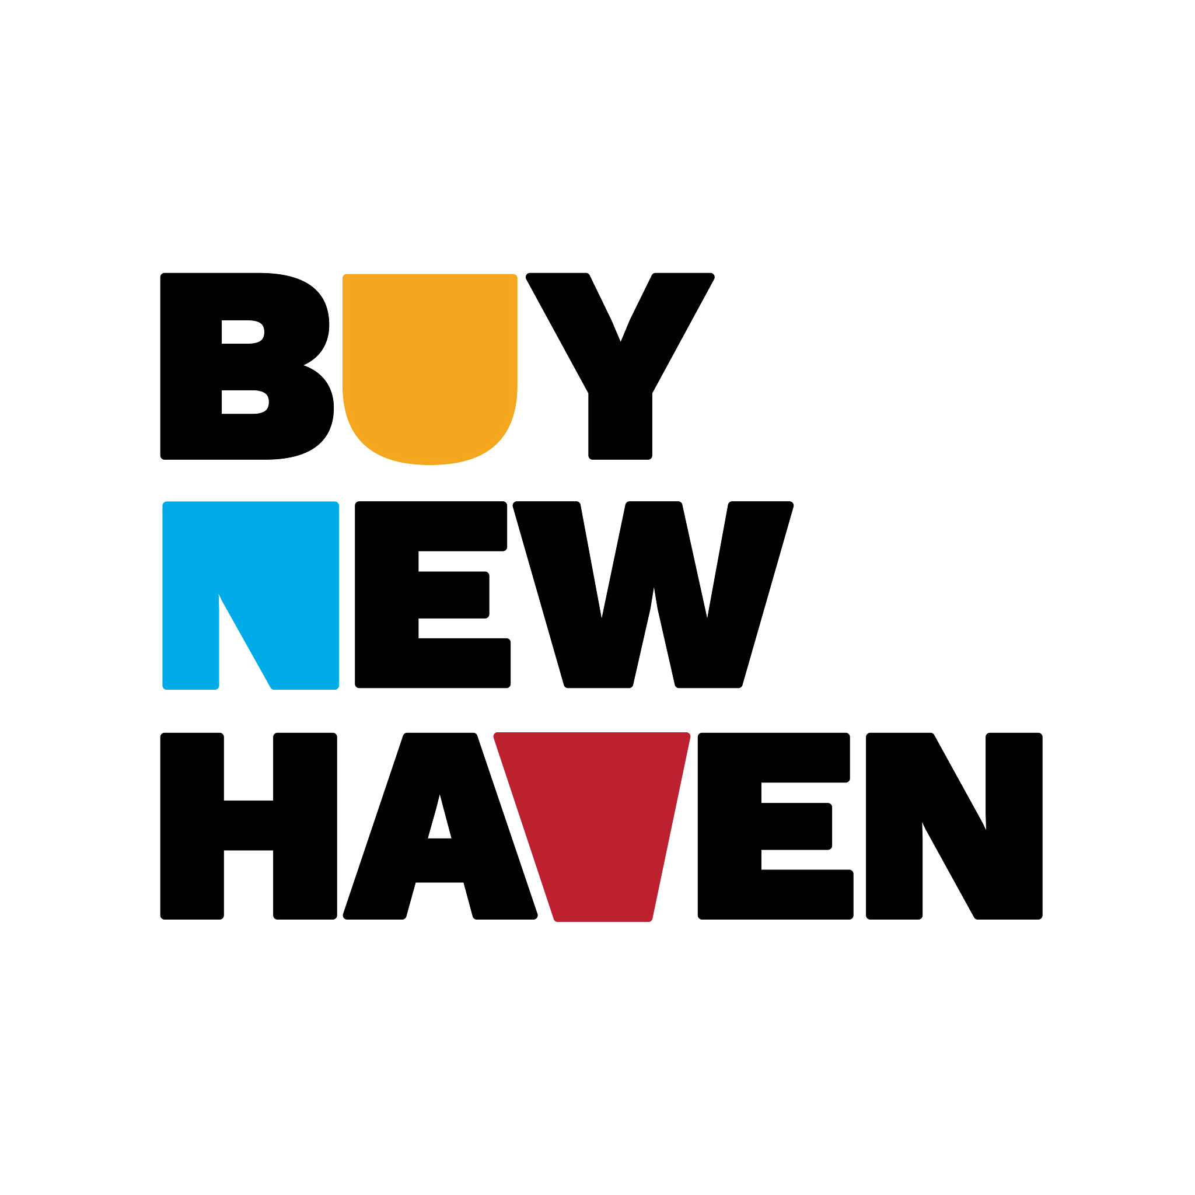
Proper Spacing and Placement:
- Maintain a clear space around the logo equal to the height of the "G" mark to prevent visual clutter.
- Always place the logo on a simple, clutter-free background for maximum visibility.
Do’s and Don’ts:
- Do: Use only approved logo variations. Ensure the logo is clear and legible in all applications. Scale proportionally without distortion.
- Don’t: Alter the logo’s colors, proportions, or orientation. Place on busy backgrounds that reduce visibility. Use unapproved effects (drop shadows, outlines, etc.).

2. Color Palette
The color palette is derived from the brand's website and logo, reflecting its innovative and forward-thinking mission.
Parent Brand Primary Colors:
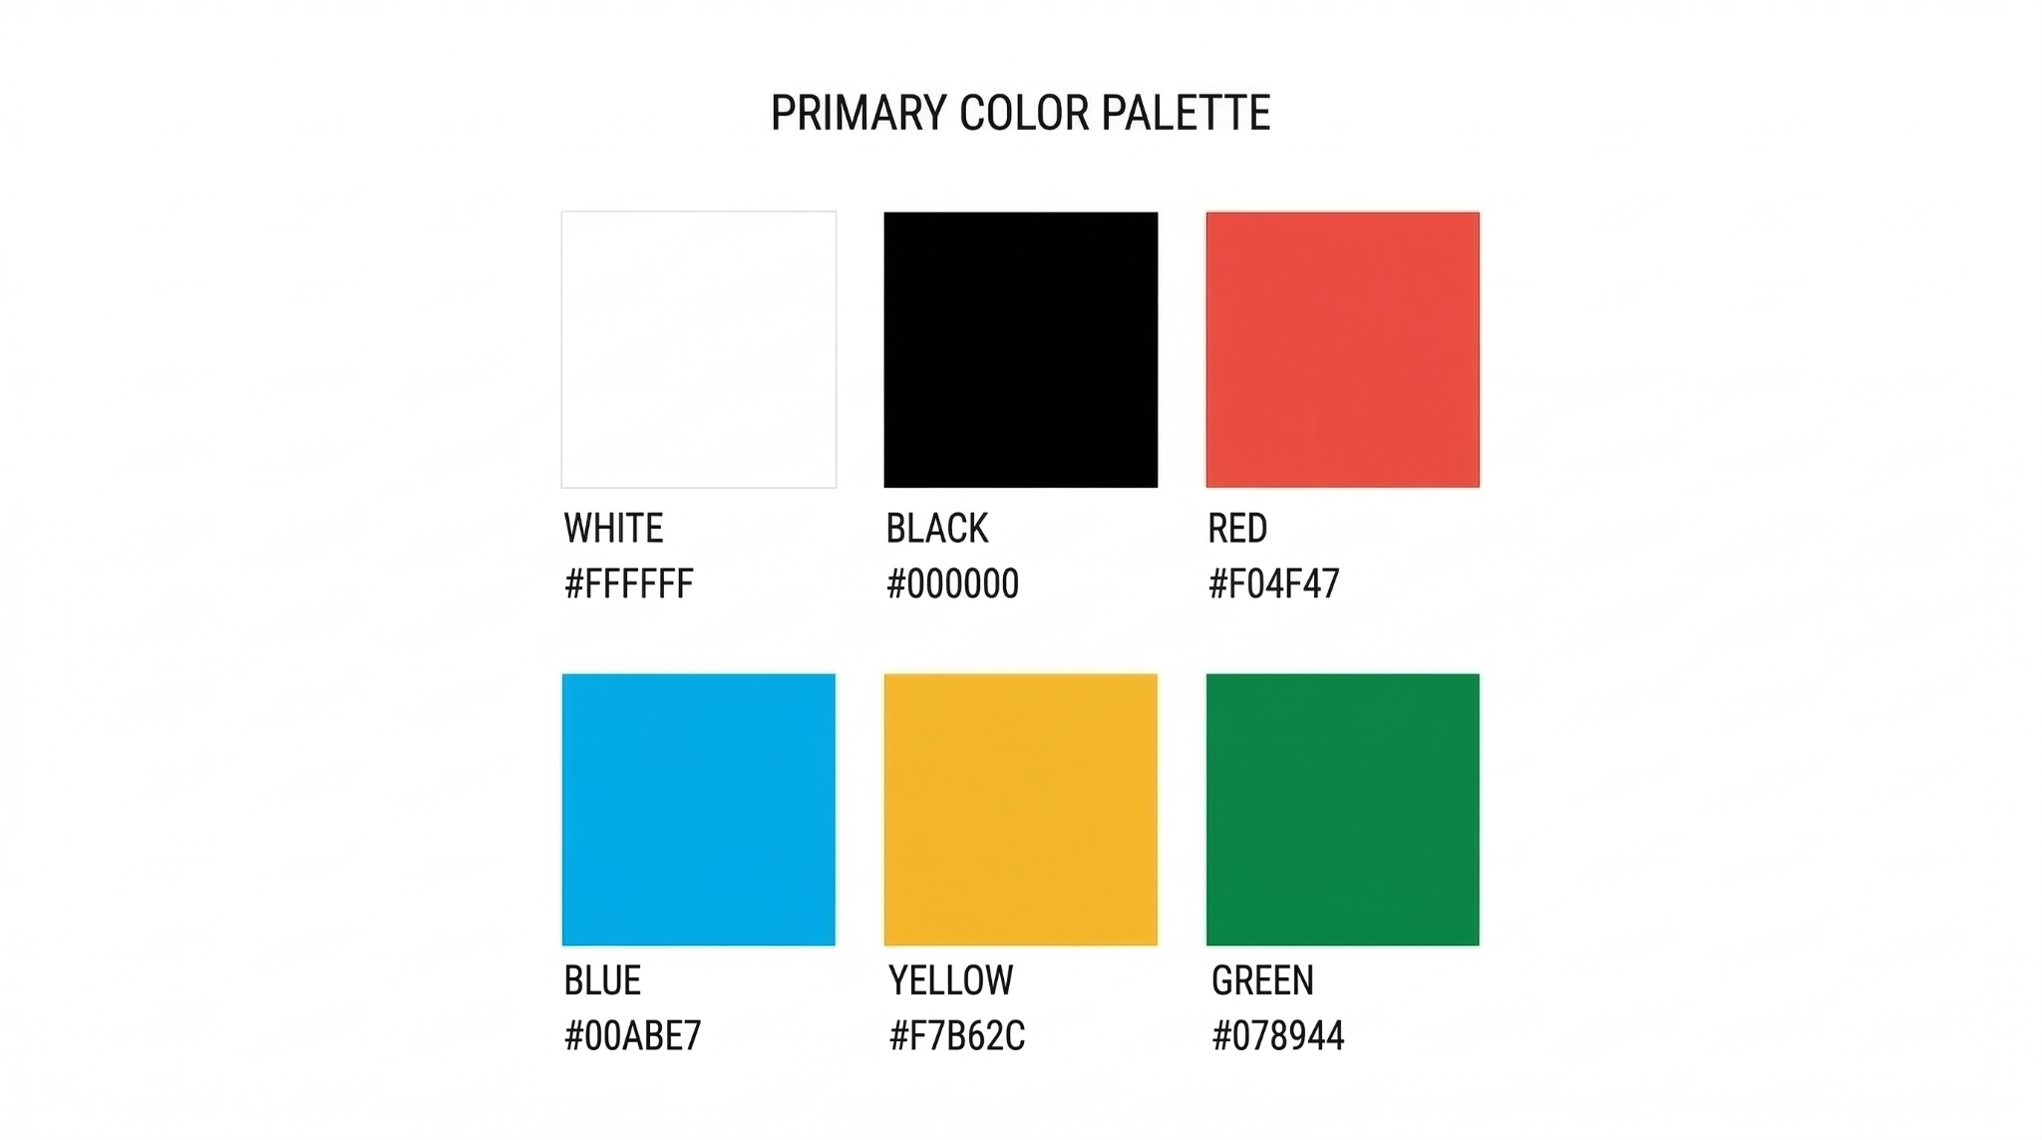

BUY NEW HAVEN Primary Colors:

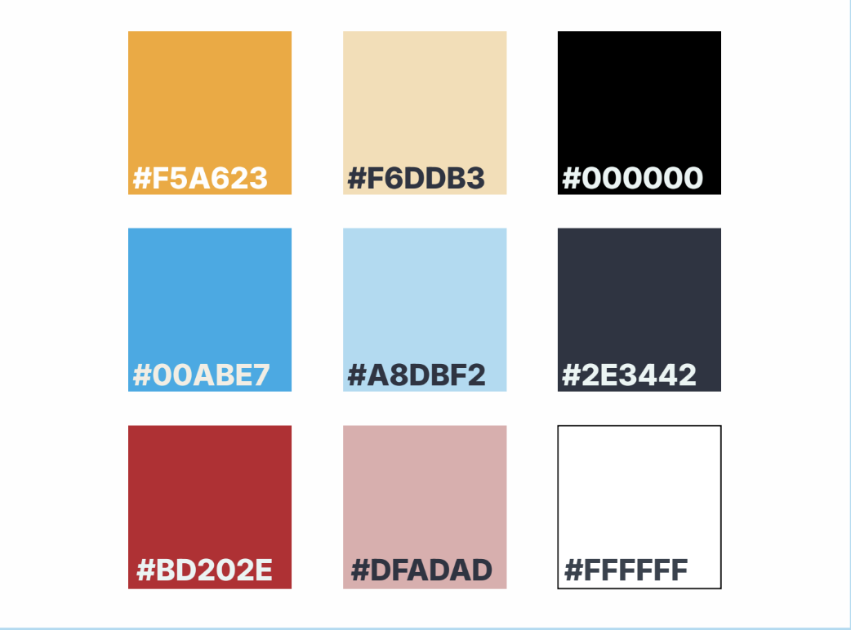
Usage Guidelines:
- Use primary colors for the logo, main headings, and key design elements.
- Use secondary colors for body text, backgrounds, and supporting design elements and when they are specific to particular programs and initiatives of The Center (i.e. BUY NEW HAVEN).

3. Typography
The brand's typography is clean, modern, and highly legible, supporting a clear and direct message.
Primary Font for the Website: Manrope
Primary Font for all written communication: Inter
Primary Font for BUY NEW HAVEN guides: Work sans
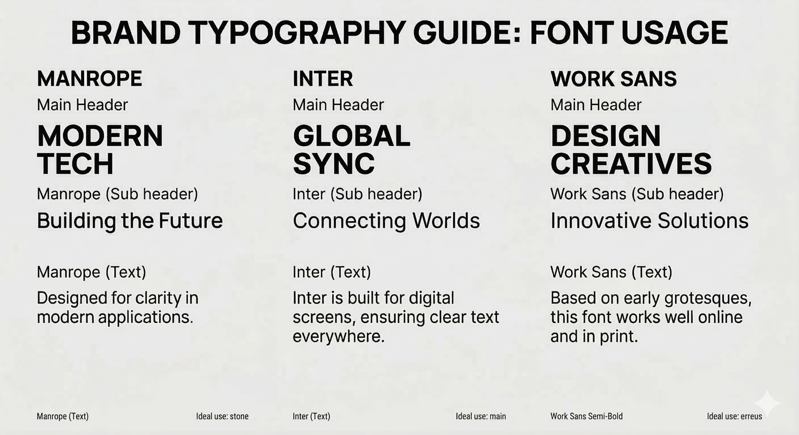
Usage Guidelines:
- Headlines should be in the title case to be approachable yet professional.
- Body text should be left-aligned and formatted for easy scanning, with short paragraphs and sufficient line spacing.
- Use the approved fonts only.

4. Imagery and Design Elements
Imagery should reflect the brand's uplifting and supportive tone, focusing on real people and positive, tangible change.
Photography Style:
- Preferred Style: Authentic, candid shots of people collaborating or engaged in meaningful work. Images should be well-lit with a warm and natural tone.
- Image Quality: High-resolution (300 dpi for print, 72 dpi for digital) is required to ensure sharpness and clarity.
Do’s:
- Show diverse individuals and communities.
- Focus on people in natural, unposed settings.
- Use a bright and optimistic visual style.
Dont’s:
- Use overly staged or corporate stock photos.
- Show images that are overly dramatic or negative.
- Use low-resolution or pixelated images.

5. Brand Voice and Messaging
The brand voice is uplifting and supportive, while also innovative, community-centered, and future-forward. The voice invokes a sense of what is possible despite what has been. It is an approachable and curious tone that is non-condescending, but when warranted, respectfully challenging. It is also direct and to the point.
Key Phrases and Taglines:
- “Economic growth for all. One step at a time.”
- "Creating what's possible, together."
- “When we BUY NEW HAVEN, we all win.”
Spellings
- Words to avoid: "Poverty," "poor," "underdeveloped," "disadvantaged" (unless quoting a direct source). Instead, use language that is more empowering like “socially vulnerable,” "financially insecure," “low wealth communities,” or "underserved populations."
Inclusive and Accessible Language:
- Diversity and Inclusion: Use gender-neutral language (e.g., "they" instead of "he/she"), culturally sensitive terms, and avoid jargon or slang that may exclude others.
- Accessibility Standards: Use clear, simple phrasing. Avoid complex sentence structures. Use plain language to ensure content is accessible to all, including those with disabilities.

6. Website and Digital Channels
The website should be clean and easy to navigate, with a clear focus on the user's journey.
Homepage & Navigation:
- Primary Menu Items: A simplified menu structure like "About," "What We Do," "Insights," "Our Impact," and "Contact" is effective.
- Call-to-Action Buttons: Buttons should be a contrasting color from the primary palette to stand out, with clear, action-oriented text like "Learn More," "Read the Report," or "Join Us."
Content Standards:
- SEO Guidelines: Use relevant keywords related to inclusive growth, economic empowerment, and social impact. Focus on creating high-quality, long-form content.
- Formatting: Use headings, subheadings, and bullet points to break up text and improve readability.
Accessibility Guidelines:
- Contrast Ratio: Aim for a contrast ratio of at least 4.5:1 for normal text and 3:1 for large text.
- Alternative Text for Images: Yes. All images, charts, and graphs must have descriptive alt text to provide context for screen readers.
- Compliance Standards: Adhere to WCAG 2.1 AA standards.

7. Social Media Guidelines
Social media content should be a mix of insights, success stories, and engaging questions.
Platform-Specific Tone & Style:
- LinkedIn: Professional, insightful, and data-driven. Share research, reports, and expert insights.
- Instagram: Visually driven and inspiring. Use high-quality imagery and short, impactful captions.
- Facebook: Narrative and reflective. Storytelling and longer form educational content
Image Dimensions:
- Post Images: Use platform-recommended dimensions (e.g., 1080x1080 px for Instagram, 1200x675 px for Twitter).
Best Practices:
- Posting Frequency: Post at least three times a week to maintain an active presence.
- Engagement Strategy: Respond to comments and questions in a timely manner. Use hashtags thoughtfully to increase visibility.

8. Applications and Templates
All branded materials should adhere to these guidelines to ensure a unified brand experience.
Email Templates:
- Newsletter Template:
  - Subject line: Clear and compelling, e.g., "The Latest from The Center for Inclusive Growth."
  - Header Image: A clean header with the brand logo.
  - CTA Button: A primary brand color with action-oriented text.
- Campaign Emails:
  - Length: Concise and to the point.
  - CTA: A single, clear call to action.
  - Formatting: Use brand fonts and colors. Avoid busy layouts

